NPTEL Online Certification : TA Guideline – JAN 2020
ENSURE THESE ARE THERE FOR NEW COURSES
Please follow the below guidelines for every week.
  - 2.0-2.5 hours or (120-150 minutes) of recorded video lectures per week
  - For each video
    - make a summary of the video with 3 or 4 points (this is to be mentioned alongside the video on the portal)
    - Ensure notes or slides, whenever available
    - provide links to additional resources
  - One “tutorial” video showing working out of problems, if applicable should be there
  - Solutions to assignment is mandatory for each week
    - Record a video working out solutions, or provide a detailed worked out solution. Just the answers are not enough.
    - Checking the assignment before making it public is most important to avoid errors. If one TA is working out answers, another can cross check them.
    - Before making the assignment public, keep the “Check answers” option on, and put in the correct answers and check if all are gotten as correct answers. Please put in different combinations of answers and check both using the “Check Answers” option and check the scores displayed in the assignment page is correct.
    - After that, turn the check answers option off and make the assignment public.
    - All assignments must be multiple submission enabled.

Types of questions in an assignment:

MCQ, MSQ – autograding / no problem(Check the score configured for each question)
  - Multiple Choice (MCQ, single correct);
  - Multiple select (MSQ, one or more correct choices);
  - Avoid using “All of the above” and “None of the above”.
  - If an MCQ has four options, blindly choosing a guess has a 25% chance of being correct. But if you have six options, that drops to 17%. With 8 options, it is 12.5%. You can go up to eight options in MCQ (more are also possible, if needed)

Fill in the blanks (numeric)
- Unless the answer is an integer, only specify a range for the answer and not an exact value.
- Answer to be entered is numeric: 0-9 and a decimal point are allowed.
- Range is preferred to allow for approximations. Range can be based on whatever error is acceptable (e.g.,if the answers are like 1.71 to 1.73, the error seems to be + or - 0.01)
- Make sure whether the range given is sufficient enough taking into account all approximations people may do.
- In some cases, if it is a 1-step problem and you may want the students to learn the importance of being precise and not round off excessively then you don't have to broaden the range.

Fill in the blanks (alphanumeric) – will be autograded
- There may be a problem with alphanumeric answers as every extra space or character in the answer will be a mismatch with correct answer and not give the user correct marks.
- Exact answer match is only possible in the portal, better to give Single word answers in this type

Document upload - manual grading

- Course staff who are the people who would be correcting the subjective assignments, should be added before the assignment is made public – else allocation will not happen.
- After evaluation, only if the scores are entered on the portal will it be visible to the students. Or atleast scores have to be published to the students through some other means.
- Evaluation deadline will be 2 weeks from the due date of the assignment
- Deletion or moving the files from the folder created causes the same to be inaccessible via the portal.
- Mention the total marks for the assignment. - Evaluation should be done out of 100

Essay type questions - manual grading - same as above.

Tips from Descriptive Courses
- Using Comprehension Passages and then providing linked questions (2-3) that require learners to go through the content once or twice
- A greater share of MSQ compared to MCQs

We normally have a few essay type questions on the final exam paper and would be good to do the following:

- Announce this prior and also give them 1 or 2 assignments with such questions to get them to practice.
- Maybe the last 2, 3 weeks assignment can have essay type so that learners get used to it. Hope the TAs can grade it.
- Create some notes to share as sample answers expected for the essay type questions in the course.

Do’s and Dont’s for NPTEL Assignments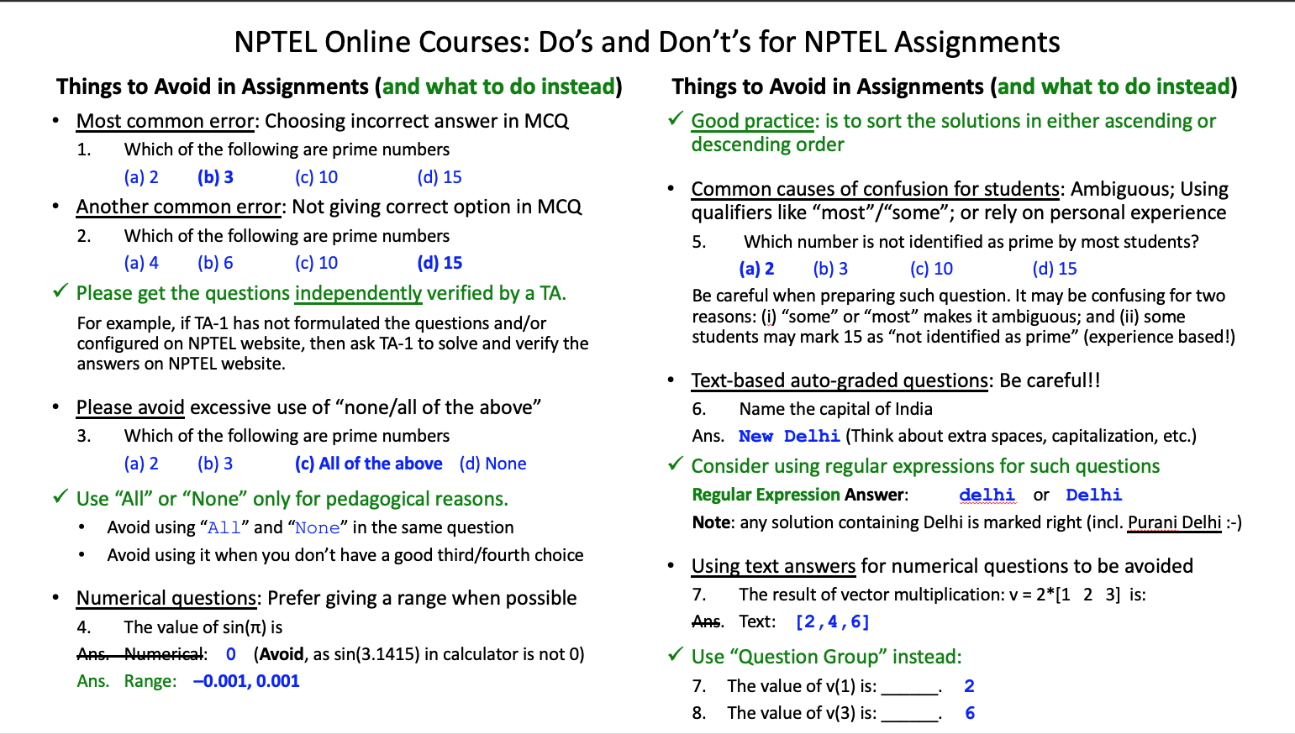

Ensure assignments are error free as else the candidates lose confidence in the final exam where we don’t release the final QPs and solutions.

FOR EVERY 10 minutes of the VIDEO:
Create 2-3 questions that the learner can use for self testing. This will be configured below the video and not graded but just used for self test.

OFFICE HOURS:
Be available one hour per week on a live session (with consent of instructor) to answer questions about the assignment that just got closed or to answer questions about upcoming assignments. We call this “office hours” where you will be available online for doubt clearing.

DISCUSSION FORUM:
Introduce yourself on the forum and check the forum atleast 2 times everyday and answer the queries raised. If there are not many queries, ask questions to start discussion.

